How to make a watermark in Photoshop cs4
Add a picture and go to the T button
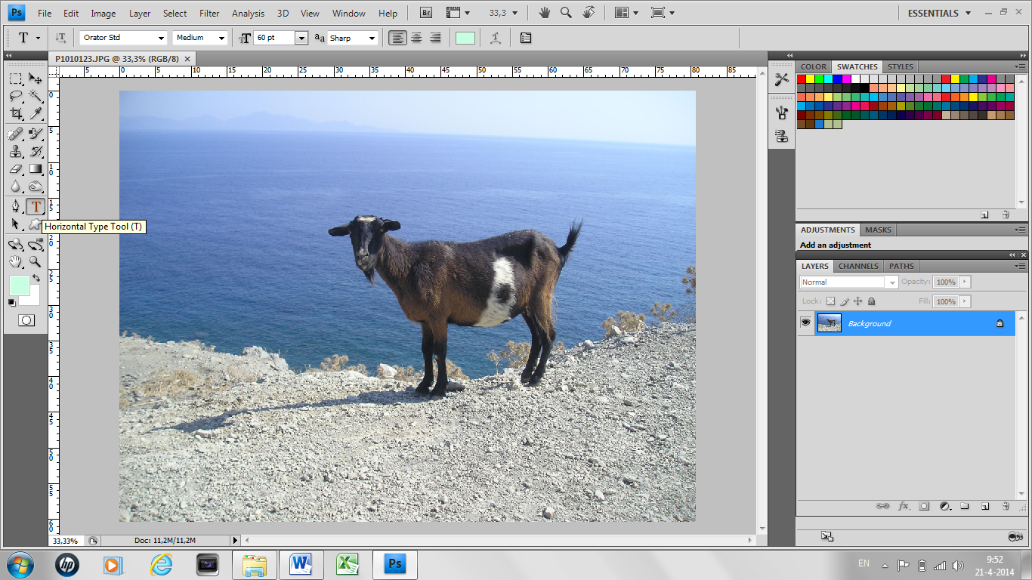

Now write the name for your watermark
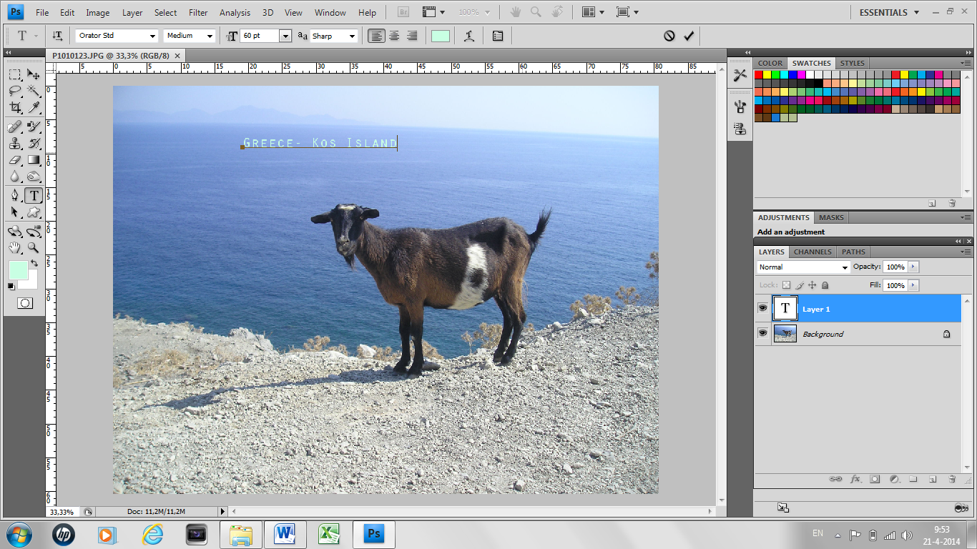

Double click at the right side of Layer 1
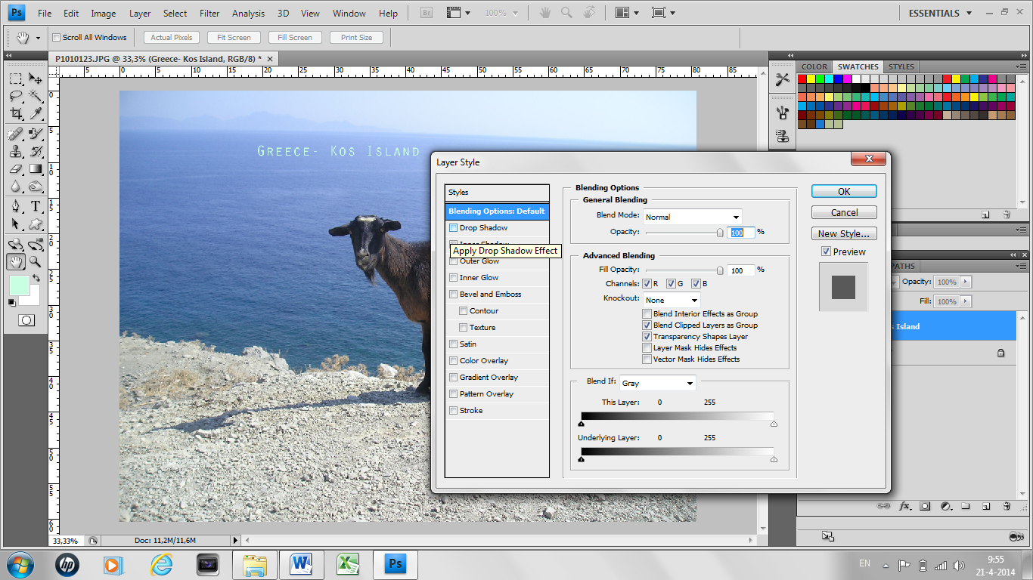

Now you can edit your watermark
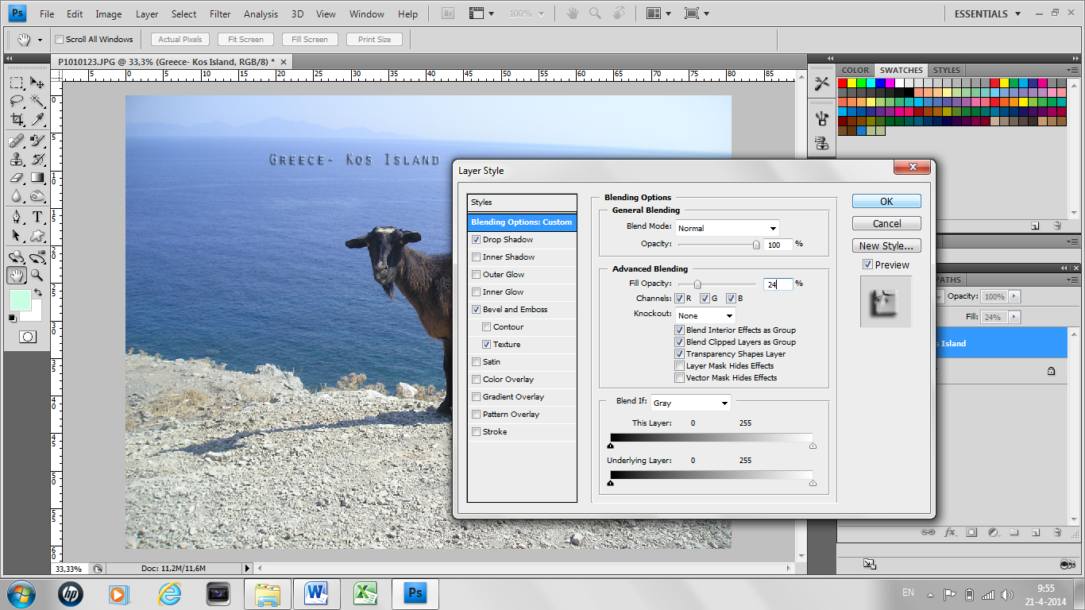

For example like picture above
Layer 1 now has the name of your watermark, click with the right mouse button on this layer.

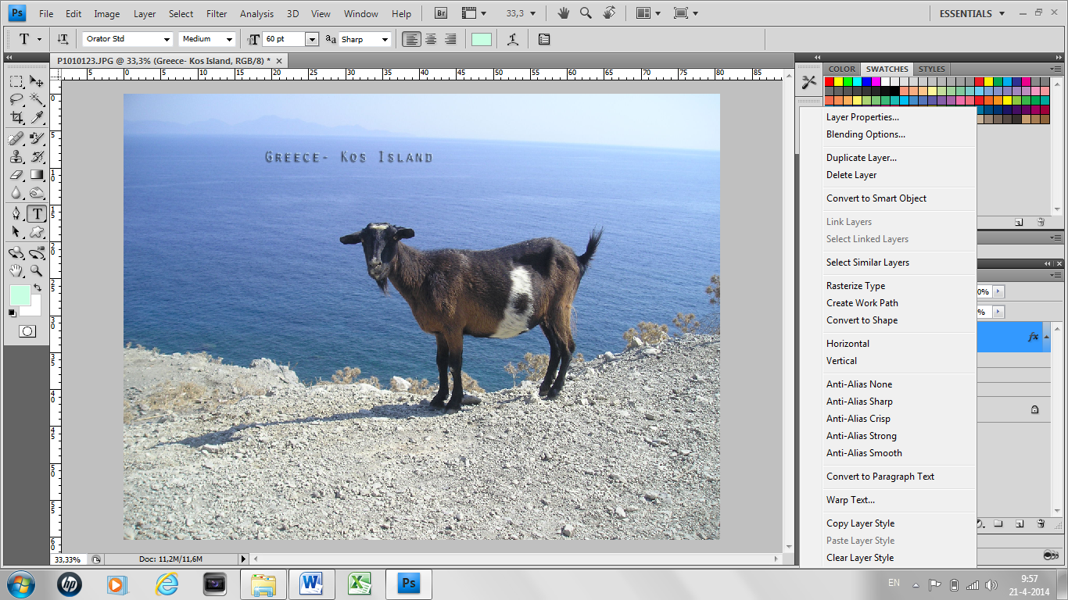
Click at convert to shape
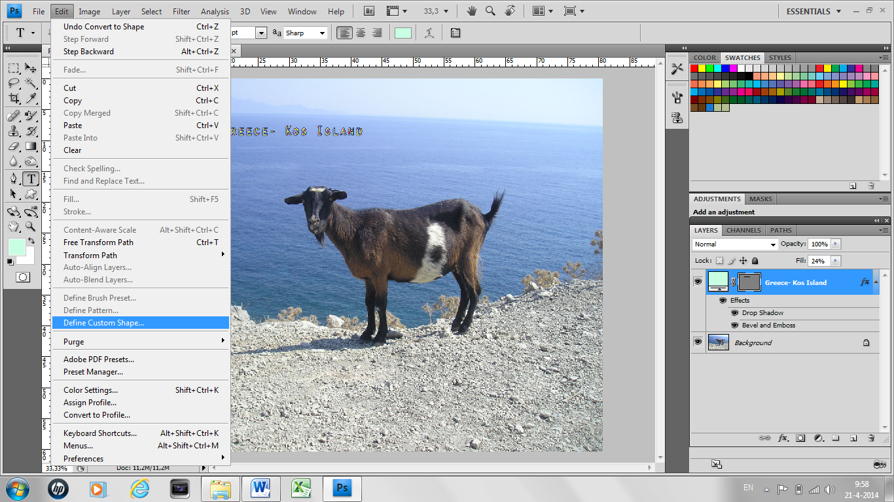
Go to Edit and click on Define Custom Shape
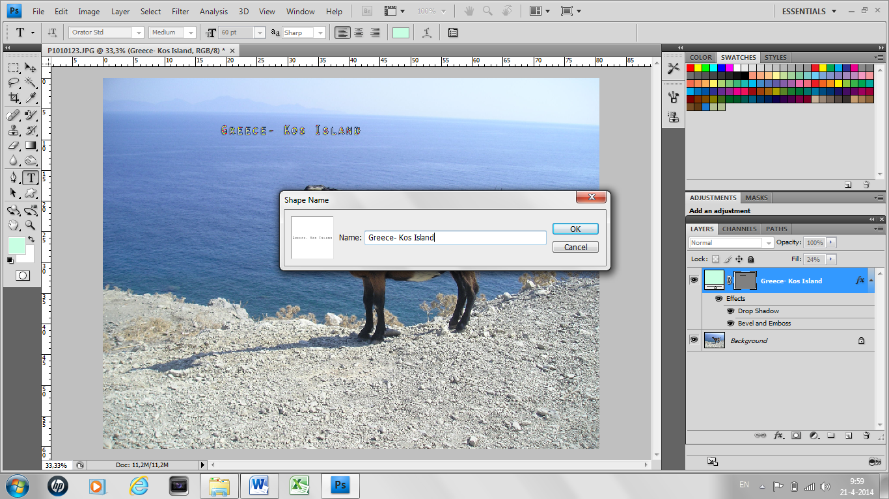

Now give your watermark a name and click on ok
Now you click on the lettre U, on top now you see the custom shape tool.
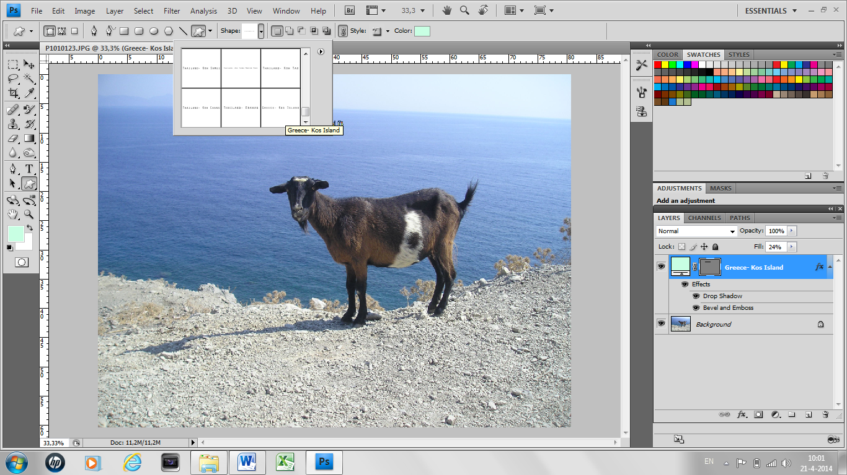
Double click on the watermark you just made
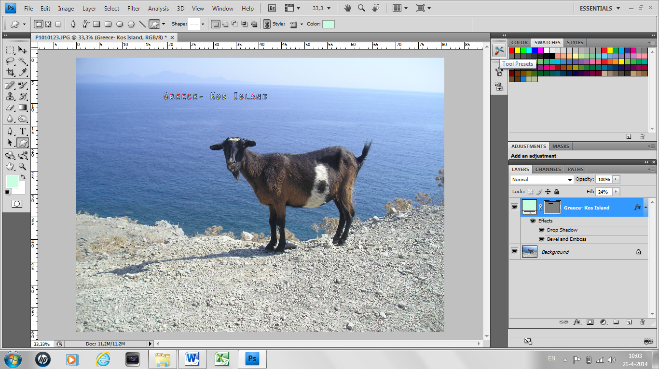

Now go to Tool presets
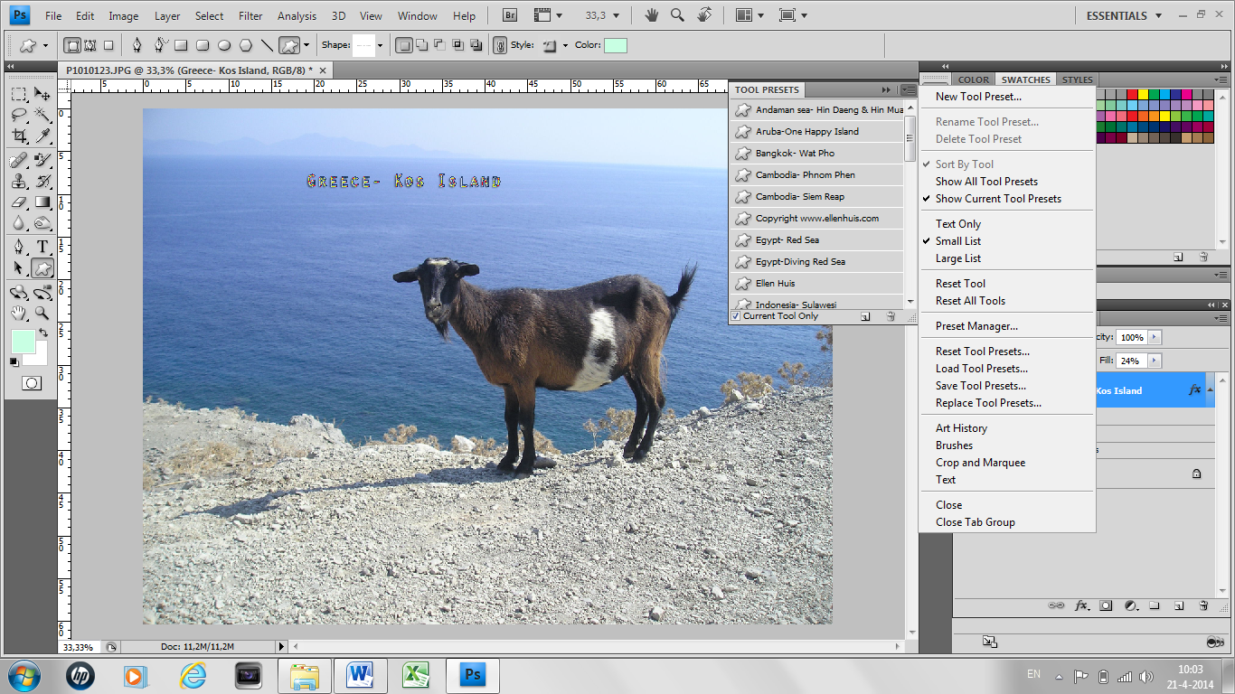
Click on New Tool Preset
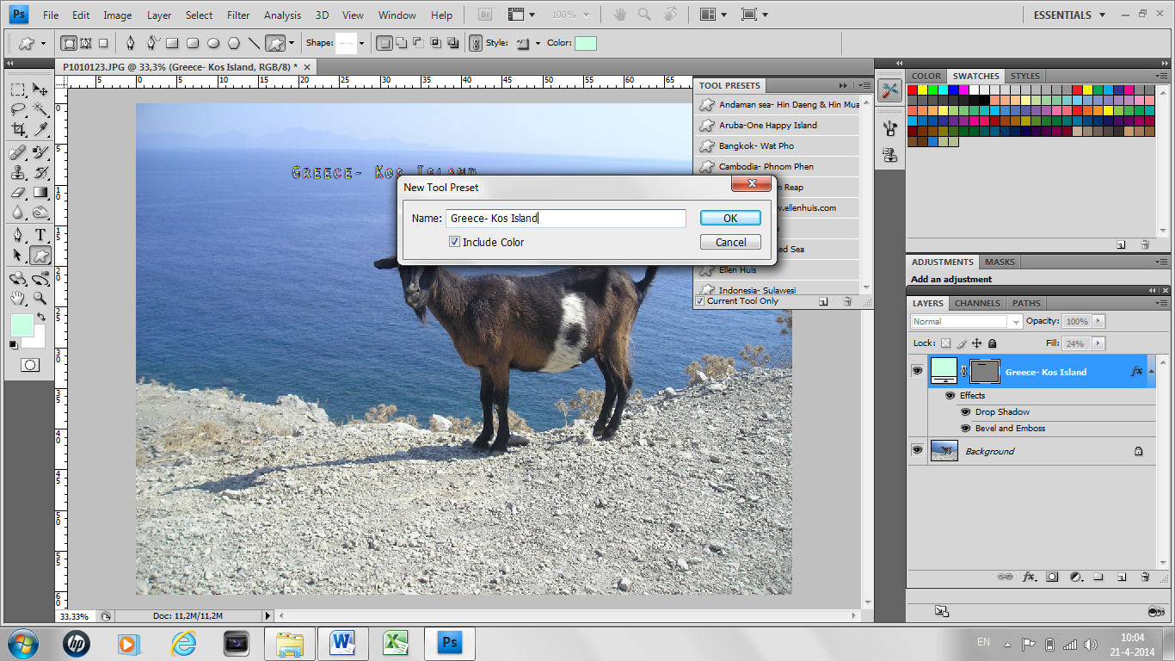
Once more give your watermark a name.

Now the watermark is in the Custom Shape Tool and you can use it.

